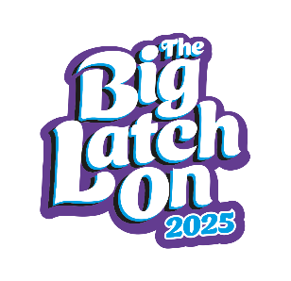

The Big Latch On Participant Registration Form
(circle one) Friday 4th / Saturday 5th / Sunday 6th April 2025

Ko te mana o te whāngai ū, ko tā te whānau whānui

“Supporting breastfeeding helps whānau and communities to flourish”
Event name & address:

Host name: |  |  | Host email:
 | Name  Please PRINT  (Everyone attending and volunteering to sign in) | Email | Participants  Total number of people attending the event with you (including children and supporters) | Photo consent (sign if you agree) *See below | Please tick if Big Latch On & its partners can stay in touch?
1
2
3
4
5
6
7
8
9
10
*Photo consent – I authorise use of my own and my child/children’s visual image and statements in newsletters, posters, internet and other advertising to promote breastfeeding and the Big Latch On.
Host statement: Please report the number of people at your event by logging into My Account at
Total number of participants at this event: ______ www.blo.org.nz and click ‘submit event count’. Contact events@wha.org.nz for help.
Name (print): ____________________________________________ Signature: ______________________________

